Excursion Policy

NQS
QA2 | 2.2.1 | Supervision - At all times, reasonable precautions and adequate supervision ensure children are protected from harm and hazard.

National Regulations
Reg | 100 | Risk assessment must be conducted before excursion.
Reg | 101 | Conduct of risk assessment for excursion.
Reg | 102 | Authorisation for excursion.

Aim
The service acknowledges the value of relevant excursions in allowing children to gain a greater insight of the society in which they live, and learn from these experiences. Our service will actively seek to minimise any risks associated with excursions, and respond promptly and appropriately to any emergency whilst on an excursion. Educators will educate children and families regarding safe road (or other transport) and play practices.

Related Policies
Acceptance and Refusal of Authorisations Policy
Staffing Arrangements Policy
Transportation Policy

Implementation
Excursion Risk Assessment and Planning Process
We will conduct a risk assessment prior to any excursion (we may use the attached Excursion Risk Assessment Form.) Risk assessments are required for excursions that are regular outings if a risk assessment has not been conducted within the last 12 months of the excursion date. Regular outings are walks, drives or trips to places that we visit regularly and which always have the same risks. We will consider the following as part of the risk assessment:
- Any risk that the excursion may pose to the safety, health and wellbeing of any child and identify how these risks will be managed and minimised
- Proposed route and destination
- Any water hazards
- Any risks associated with water-based activities
- Transportation (to and from)
- The ratio of educators and children which must comply as a minimum with the ratios in the Staffing Arrangements Policy
- Whether extra adults are required for supervision and safety
- Specialised skills required (such as life-saving skills)
- Proposed activities
- Proposed duration
- Any medical conditions that need to be considered and managed for each child with specific health needs
- Items that should be taken

A parent or authorised person must provide written authorisation for the excursion (see Authorisation for Excursion Form attached). This authorisation only needs to be obtained once every 12 months for regular excursions. The authorisation will include:
- Child’s name
- Date of excursion (unless regular outing)
- Destination and proposed activities
- Mode of transport
- How long the child will be away from the centre
- Expected number of children attending
- Expected ratio of educators to children
- Expected number of additional adults who will be attending
- Advice risk assessment available at service and it can be viewed prior to excursion

We will request current emergency contact numbers when obtaining the authorisation.

We will provide at least 24 hours notice of the excursion to parents. This notice period will generally be at least two weeks.
The Excursion Checklist will be implemented prior to any excursion.
Transport Considerations
The means of transport must be stated on the permission note.
Buses – ensure that the seating capacity as displayed on the compliance plate is not exceeded. All children must sit on seats, preferably with, or close to, an adult. Seat belt guidelines must be followed depending on the bus. If the bus has seat belts, they must be worn at all times.
Trains – contact the station prior to the excursion to inform them of the time you will be travelling, the destination and the number of children and adults who will be travelling. Arrangements should be made to arrive at the station with an adequate amount of time to allow for safe boarding. This will allow the station to inform the train guard so that he / she can hold the train for the period of time for safe boarding and alighting. All children should be seated at all times, with an adult close by. All children should be seated in the one carriage, if possible.
Cars – Any motor vehicle that is used to transport children on an excursion (other than a motor vehicle seating more than nine persons) is fitted with child restraints and/or seatbelts that are appropriate for the age and weight of each child, that conform to the Australian Standards, and are professionally installed or checked by an authorised restraint fitter.
Insurance
Any excursion planned must be consistent with the requirements / exclusions of the Public Liability Cover held by the service.
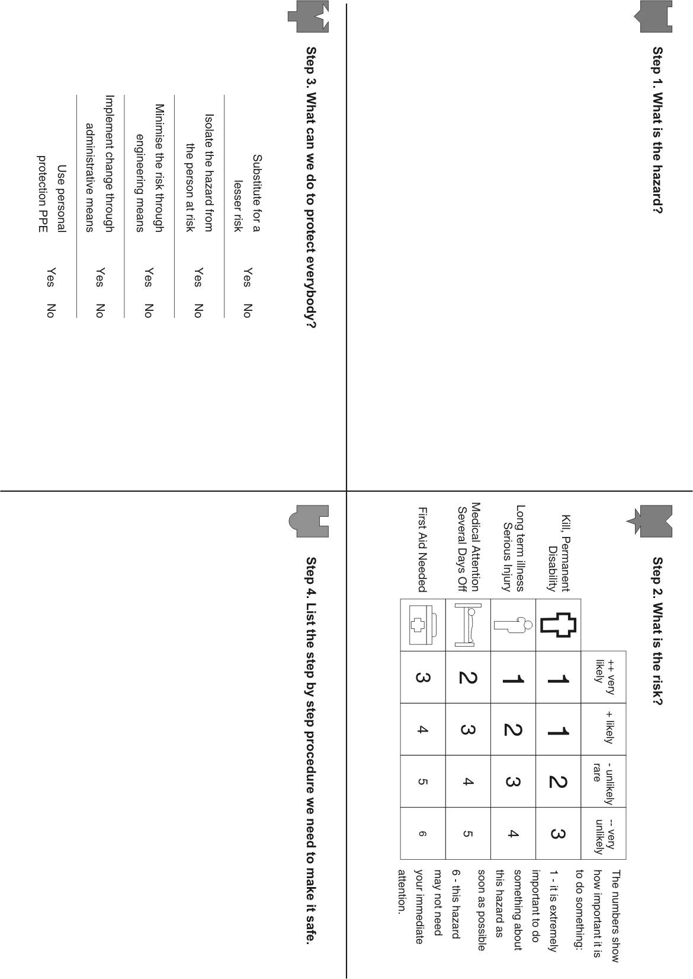
Excursion Risk Assessment Form
As a part of the Excursion Risk Assessment we will consider the following details:
Time and Date of Proposed Excursion
__________________________________________________________________________________
Destination (s)
__________________________________________________________________________________

Proposed Route (to and from)
__________________________________________________________________________________
__________________________________________________________________________________
__________________________________________________________________________________
Water hazards
__________________________________________________________________________________
__________________________________________________________________________________
Transportation Details (to and from)
__________________________________________________________________________________
__________________________________________________________________________________
__________________________________________________________________________________
Number of Educators Attending
__________________________________________________________________________________
Number of Children Attending
__________________________________________________________________________________

Ratio of Educators to children
__________________________________________________________________________________

Number of Additional Adults Required
__________________________________________________________________________________
Specialised skills needed to ensure children are adequately and safely supervised at all times (eg life-saving)
__________________________________________________________________________________
Proposed Activities
__________________________________________________________________________________
__________________________________________________________________________________
__________________________________________________________________________________
Availability of shade
__________________________________________________________________________________
__________________________________________________________________________________

Proposed Duration
__________________________________________________________________________________
Specific health care needs or medical conditions that need to be managed
__________________________________________________________________________________
__________________________________________________________________________________
__________________________________________________________________________________

Items to Be Taken by the Service (mobile phone, emergency contact details, etc)
__________________________________________________________________________________
__________________________________________________________________________________
__________________________________________________________________________________
Items to Be Taken by the Children
__________________________________________________________________________________
__________________________________________________________________________________
__________________________________________________________________________________
Authorisation for Excursion Form
Our service has organised an excursion for your child to attend. All of the relevant details are provided below for your convenience. The service has conducted an Excursion Risk Assessment which is available for your review upon request. For your child to attend, you are required to read this information and complete the Authority for Excursion Form. To complete this Form, you must be the child’s parent or authorised on the child’s enrolment record to authorise this excursion.
This excursion is a Regular Outing and this authorisation will cover the regular outing for 12 months. Please note that the Authority can be cancelled at any time.
Child’s Full Name
__________________________________________________________________________________
Time and Date of Proposed Excursion
__________________________________________________________________________________
Destination (s)
__________________________________________________________________________________
Reason for Excursion
__________________________________________________________________________________
__________________________________________________________________________________
__________________________________________________________________________________
Proposed Activities
__________________________________________________________________________________
__________________________________________________________________________________
__________________________________________________________________________________

Route (to and from)
__________________________________________________________________________________
__________________________________________________________________________________
__________________________________________________________________________________
Transportation Details (to and from)
__________________________________________________________________________________
__________________________________________________________________________________
__________________________________________________________________________________
The Period Children will be Away from the Service
__________________________________________________________________________________
Number of Educators Attending
__________________________________________________________________________________
Number of Children Attending
__________________________________________________________________________________

Ratio of Educators to children
__________________________________________________________________________________

Number of Additional Adults Attending
__________________________________________________________________________________
Items to Be Taken by the Child and Provided by the Parents
__________________________________________________________________________________
__________________________________________________________________________________
__________________________________________________________________________________
Authority for my Child to Attend the Excursion
Full Name
__________________________________________________________________________________
Relationship to Child
__________________________________________________________________________________
Current Emergency Contact Details (home or mobile phone number, email )
__________________________________________________________________________________
__________________________________________________________________________________
Interested in Volunteering to the Attend the Excursion? Please circle Yes No
By signing the Authorisation for Excursion Form, I agree to and understand the following –
- My child has my permission to attend the excursion listed. If the excursion is a regular outing, my child has permission to attend for 12 months after the date listed below
- I am listed on the child’s Enrolment Form as a Parent or authorised on the child’s enrolment record to authorise this excursion
- I have read all of the details provided by the service and understand that I can access the Excursion Risk Assessment at the service

Signature
________________________________________________________________________________
Date
________________________________________________________________________________
Excursion Checklist

Please circle

yes | no | N/A | A risk assessment has been completed and steps taken to minimise any identified risks
yes | no | N/A | A signed authorisation for the specific excursion and any specific activity which is to take place during the excursion has been received. Regular outings can be covered by one form for a period of 12 months
yes | no | N/A | A list of children attending the excursion will be left at the service prior to departure and a copy carried by the Supervisor who will cross check against the children at regular intervals during the excursion
yes | no | N/A | All children are equipped with appropriate clothing for the excursion.  For example - jumpers, sun hats, appropriate footwear, sunscreen
yes | no | N/A | Children will have access to shaded areas
yes | no | N/A | The excursion is consistent with the requirements/exclusions of the Public Liability Insurance Cover held by the service
yes | no | N/A | Educators are taking a fully stocked first aid kit
yes | no | N/A | Educators are taking each child’s current emergency contact details
yes | no | N/A | A mobile phone or change for a phone will be taken. Office staff know the mobile number
yes | no | N/A | A designated educator has been assigned to directly supervise any child with a chronic illness/allergic condition, and will carry the child’s medication and current medical management plan throughout the excursion
Sources
Education and Care Services National Law and Regulations
National Quality Standard

Review
The policy will be reviewed annually by:
- Management
- Employees
- Families
- Interested Parties
Last reviewed: February 2024 Date for next review: yearly

